Nutritional Discordance

Lila Cardell and Erin Lentz

# Introduction

Women and girls are commonly assumed to be at greater risk of food insecurity (e.g., UN Women 2012). Earlier research examined whether women consume a lower percentage of their required daily caloric intake (e.g., Haddad and Kanbur (1990); Berhman and Deolaliker (1990); Pitt et al. (1990); Haddad et al. (1995)), but, as Marcoux (2002) summarized, “evidence of pro-male biases in food consumption is scarce” (p. 275).

In recent years, as nutritional measures have moved away from caloric intake, this claim has been reconsidered. More recent findings suggest that there is meaningful nutritional inequality within households. Much of the earlier research used caloric intake measures. Recent research has focused on richer nutritional intake and outcome measures, such as dietary diversity (Mangyo 2008; Villa et al. 2011; Rahman 2013), nutrient adequacy (Coates 2017 and Coates 2018), and body mass index (Sahn 2009; D’Souza and Tandon 2018). This resurgent interest in understanding intra-household nutrition reflects the recognition that calories are just one measure of nutritional status.

New studies measuring differences in nutritional status within households, which we refer to as nutritional discordance, find …

It is likely numerous attributes, such as cultural and social norms and institutions influence the degree of nutritional discordance across study sites. However, studies use both a wide variety of methods and a wide variety of nutritional measures to come to these conclusions. As a result, such findings are not directly comparable, and we have less sense of whether the degree nutritional discordance we observe is an artifact of the measures used or reflects the underlying data. The objective of this paper is to disentangle how the choice of method and choice of nutritional measure impact findings for a single country: Bangladesh.

Currently, researchers are required to make a series of choices about how to measure discordance, and there is little-to-no consensus on best practice. For example, some approaches ignore activity intensity of each individual. Individuals working in higher-intensity occupations may have greater caloric requirements compared to those who do not. If men are expending a greater proportion of energy in high-intensity activities than women, failing to account for energy expenditure can make results appear more inequitable than they truly are. The nutrient-reference tables used in low-income country studies also differ. In some cases, USDA reference tables are used, even though the foods’ nutrients may vary (e.g., sweet bananas in the US differ from staple bananas in Uganda). As a result of this variation, we know little from current studies about whether findings of nutritional discordance are sensitive to the choice of method or measure.

This research has two aims. First, we make a methodological intervention to learn the extent to which measurement choice influences findings of nutritional discordance. This can help us to determine when and where relying on unitary models of households is appropriate. Where appropriate, collecting household level data rather than individual level data can result in significant time and cost savings. However, a risk of assuming unitary households is that we misidentify the number of food insecurity individuals and the severity of the insecurity experienced. Brown et al. (2017) argue there is “substantial intrahousehold inequality” in sub-Saharan Africa, where being an undernourished woman is only weakly correlated with poverty status. Lentz et al. (2019) show that women eat last and least and consume fewer high-quality quality foods than other household members in rural South Asia. These and other studies raise questions about the continued reliance on unitary household models for food, agriculture and nutrition research. An important step is to identify how sensitive results that are discordant are to the choice of method.

Second, based on our findings, we aim to provide guidance on best practices for measurement. A better understanding of nutritional discordance is critical for food, agriculture, nutrition, gender, and social protection policy. For example, while efforts to link agriculture-to-nutrition remain widespread, achieving improved nutrition remains challenging (see Kadiyala et al. 2014). Similarly, an expanding interest on women’s empowerment (e.g., Pratley 2016; Santoso et al. 2020) raises questions of when and how gender inequality manifests itself within households. A clearer understanding of how to measure such effects, and when it is useful to do so can help researchers and practitioners recognize when household bargaining matters and how to design program interventions better achieve desired impacts.

In the next section, we describe the methodological choices researchers face when computing nutrient intake for household and individual level survey data. In section 3, we describe our data and present our summary statistics. In section 4, we share results, including the sensitivity of the nutrient intake to the various approaches and parameter choices. We conclude in section 5 with a discussion. By identifying relationships between measures, approaches, and parameters, we aim to make recommendations for best practices for measuring nutritional inequality, given data and temporal limitations.

# Methodology

Researchers face multiple decisions points when computing nutritional discordance. In theory, the goal is to identify how many and which foods (and therefore macro and micronutrients) each household member consumed and compare those amounts against other members’ intakes within a household. However, to engage in this comparison requires multiple choices, such as whether and how to adjust intake requirements by activity level.

Using Bangladesh as a case study, we show that from the initial selection of data to the final inequality measure, these choices influence research outcomes. Figures 1 and 2 map the pathways for research starting with household level survey data and individual level survey data, respectively. The rectangles indicate possible decision-points, where researchers face choices regarding (1) which food composition table to use and how to adjust for bioavailability and retention (2) which individual nutrient requirements to use and how to adjust them to reflect life stage and level of physical activity and, (3) in the case of household data, how to convert the nutritional needs of household members into adult equivalents. We discuss each of these decision points and the figures in greater detail below. The numbering of each section corresponds with the pathways in Figures 1 and 2.

**1. Survey Data:**

In Figure 1, the first step is to distinguish two different data sources: household expenditure and consumption surveys (HCES) and household food diaries. HCES report household recall of purchases of food and non-food items and consumption over a set time period, often 7 days. Household food diaries typically track food intake over a 24-hour period. Household budget surveys, Living Standard Measurement Studies, Comprehensive Food Security Assessment Surveys are all examples of HCES.

Factors that can affect the quality of the results of a HCES include the length of time covered by the survey, the types of categories or options provided to the enumerators, the likelihood of food consumed away from home, and the level of literacy and urbanization of the household (Fiedler, et al. 2012). In sum, these surveys are widespread, but not without error. Comparisons of HCES and household food diaries have found that they are comparable in their collection of relevant consumption data (Fiedler, et al. 2012).

While HCES and household food diaries are less costly and easier to collect than individual-level survey data, they provide little or no information on how most food items are apportioned in the household. (Murphy, et al. 2012, Fiedler, et al. 2012, Sununtnasuk and Fiedler 2017). As a result, findings from household level survey data must make assumptions about who is eating what. In places with significant intrahousehold dietary inequality (e.g., see Lentz et al. 2019 describing gender-differences in consumption in rural South Asia), there is a significant risk of understating nutritional discordance.

Figure 2 demonstrates the pathway beginning from individual level survey data, which can be in the form of consumption diaries or recalls or observed food weight records (OFWR). Considered the gold standard for individual consumption data: OFWR capture video or photo of food consumed and allow the researcher to determine the quantity and quality of the food, while their cost makes them difficult to implement at scale (Fiedler, et al. 2012, Lividini, et al. 2013). Individual consumption diaries or recall surveys often ask the respondent to identify consumption over a 24-hour period. This short time frame can miss day -to-day variation in consumption patterns or preferences that can only be seen with a longer survey period (Murphy, et al. 2012).

A final source of nutritional discordance data is anthropometric measures of individual heights and or weights, or biomarkers serum to measure nutrient status. The cost of administering these tests and the training necessary to implement them are non-negligible (Murphy, et al. 2012). On their own, anthropometric findings can identify discordance; however, identifying whether food intake may contribute to these discordance measures requires additional data collection.

**2. Food Composition Tables:**

Food composition tables (FCT)are used to convert the food items reported in the dietary data sets into energy and nutrient values. Chemical analyses determine the nutrient context of the foods in the food composition tables (CITE). The United States Department of Agriculture, for example, provides a comprehensive database FoodData Central which contains data on food and nutrients for both items prepared at home or away from home. This database has been used extensively for non-US based research (e.g., Bermudez, et al. 2012, Lividni, et al. 2013) However, the quality and nutritional profile of foods can vary both across and within countries. For these reasons, research in non-US countries, it may be preferred to use regional food composition tables, which may provide greater accuracy in nutrient content and contain the local names of items to increase likelihood of identification (Behrman 1998, Sununtnasuk et al. 2017, Coates 2018, D’Souza and Tandon 2019). Finally, a combination of food composition tables may be required to identify all consumed items, as well as to standardize food sizes and quantities. Adjustments can also be made for bioavailability of nutrients and cooking retention factors (Coates 2017, Karageorgou, et al. 2018).

**3.** **Reported household or individual consumption for each nutrient:**

The household or individual level consumption data is then matched to the food composition table(s). FAO provides the “FAO/INFOODS Guidelines for Food Matching” (2012) which recommends checking the name and description of the food item, as well as the scientific name, water and fat content. The form of the food that it is reported: fresh, dried, cooked, raw, etc. will affect how the food composition table is applied. If the reported item is a cooked dish, the USDA (2007) provides tables of nutrient retention factors that can be used to adjust the nutrient composition from raw to cooked form. Often, adjustments must be made if the survey data if presented in a different unit than the food composition table. After the survey food items are matched to data in the food composition tables, this yields the total reported nutrient consumption by the household or individual.

**Note:** Figures 1 and 2 show that the type of survey data available (household or individual) will change the calculation of nutrient intake. If using individual level data, the **reported individual consumption** can be compared directly to the nutrient requirements. If using household level data, additional steps must be taken to derive the **allocated individual consumption** of the nutrient, which is then compared to individual nutrient requirements. The process of deriving the allocated individual requirement relies on the requirements themselves. However, once individual nutrient intake is computed, the prevalence and intensity of inadequacy can be calculated by comparing the individual reported or allocated consumption of the nutrient to the nutrient standard.

**4. Nutrient Requirement Sources:**

The decision of nutrient requirement is the source of most variation in outcomes. There have been proposals to harmonize nutrient standards across countries and methodologies (Allen, et al. 2019), but there is not yet convergence on nutrient standards. Researchers must choose (1) reference standards for nutrient requirements, and the appropriate reference standard for the group or individual, which includes decisions about incorporating (2) physical activity levels (3) life stage and (4) height and weight. More precision on these attributes increases the likelihood that the appropriate nutrient intake standard is used as a benchmark. For example, a sedentary woman aged 65 and five feet tall does not require the same nutrients as an 18-year-old, physically active six foot tall man. While some datasets do not include all pertinent information about the latter three attributes and therefore researchers are forced to use a reference group that fits the characteristics available, some researchers also make simplifying assumptions, ignoring, for example, activity levels. This section considers the basic information needed to allocate household consumption to individuals. In step 8, we discuss the specific process of determining inadequacy. We investigate the influence of such decisions in the results section below.

*Choice of nutrient requirements standards*

The Institutes of Medicine (IOM), a joint United States (US)-Canadian effort, published the *Dietary Reference Intakes* (DRI) in 2006, covering energy, carbohydrates, fats and fatty acids, protein, and amino acid requirements, as well as micronutrients.[1] These are considered the gold standard by nutritionists, and are updated periodically. The US also posts dietary guidelines for recommended intake, although the US guidelines are used infrequently (Brown, et al. 2019).

Given that the DRIs were developed for and by the US and Canada, there is a reasonable concern over the applicability of these standards to global populations. However, there is no alternative as comprehensive with the respect to the range of nutrients, or as validated by the scientific community. The World Health Organization (WHO) and U.N. Food and Agriculture Organization (FAO) published energy requirements (FAO 2004) and recommendations for nutrient intakes for protein (2002), energy (2005), carbohydrates (2007), fats and fatty acids (2010), and vitamins and minerals (2004.) The WHO guidelines are a valuable resource for weight and height assessments and targets for global populations (Schenider and Hertforth 2020, Allen, et al. (2019). The WHO/FAO requirements are generally used for energy requirements, complementary to IOM standards for micronutrients (Bermudez. et al. 2012, Lividni et al. 2013, Sununtnasuk et al. 2017, Coates 2017).

The diversity in the weights, heights, and nutritional characteristics of different populations begs the need for regional requirements, which exist in selected countries. The National Institute of Nutrition published Dietary Recommendations for Indians in 2011, which provide recommendations for protein, fat, calcium, and iron and energy intakes based on an average weight and height for sex, age, and life stage groups.

*Physical Activity*

Active individuals require more nutrients than sedentary. The delineation of individuals by physical activity level can affect the individual nutrient requirements and likelihood of an individual being identified as inadequate. All three sets of nutrient standards mentioned adjust energy and often nutrient requirements based on classification of physical activity level. The DRIs provide 4 categories: sedentary, low active, moderately active, and high active and adjust energy requirements based on a multiplier for each category. The WHO/FAO requirements provide ranges of multipliers for adjusting energy requirements within low, moderate, and heavy categories. The Indian National Institute of Nutrition (NIN) requirements are provided for each category, without provision of the underlying calculation. Some papers, either due to lack of data or as a simplification, classify all individuals as moderate (Karageorgou, et al. 2018, Coates 2017, Coates 2018, D’Souza and Tandon 2019), while others allocate activity category between “light”, “moderate”, and “active” based on occupation category. One resource is to identify the appropriate activity level by occupation as in Steeves et. al. (2015), who used accelerometry data collected in 2003-2004 from over 1000 adults in the United States, to allocate individuals into three groups based on occupation.

*Life stage*

Nutrient requirements do not increase monotonically with respect to age. Children, pregnant, and lactating women have different nutrient requirements and require adjustments to calculations. For example, iron requirements for pregnant and lactating women differ than for other women.[2] The IOM, WHO/FAO, and India nutrient standards all provide recommendations specific to life stage group. However, it is not always possible to identify from survey data whether an infant is fully or partially breastfeeding, or how far along a woman is in her pregnancy. One option is to eliminate all children under 2 years of age, and pregnant and lactating women (D’Souza and Tandon 2019, Brown, et al. 2019). Another is to estimate pregnancy and lactation status within a 3-6-month window and assign the average requirements for that window (Sununtnasak and Fiedler 2017).

*Reference Heights and Weights*

The IOM energy recommendations (and any nutrients that are a percentage of energy requirements) rely on incorporation of a weight, height, age, and physical activity level for a given sex and life stage group. The WHO/FAO energy requirements (and some nutrient requirements) rely on a weight and physical activity level for a given age, sex, life stage group. Thus, for IOM and WHO/FAO calculations, the choice of weight, height, and age can have a significant impact on energy needs. The India energy and nutrient requirements are provided by age, sex, physical activity, and life stage group, for a set reference height and weight that is also given for that group.

When individual height and weight data are available, researchers can create individual-specific requirements by using the individual’s current weight and height, resulting in an Estimated Energy Requirement (EER). The EER is “the average dietary energy intake that is predicted to maintain energy balance in a healthy adult of a defined age, gender, weight, height, and level of physical activity consistent with good health” (IOM 2006). The WHO/FAO equivalent is the Total Energy Expenditure (TEE) which is the “energy spent, on average, in a 24-hour period by an individual, or a group of individuals.” (FAO, 2004)

In cases where individuals’ heights and weights are not collected or as a simplifying assumption, the calculations for energy or nutrient requirements are made for the entire age, sex life stage group using the reference height and weight determined by the reference standard. While IOM, WHO/FAO, and India all provide reference weights and heights for age, sex, life stage groups, the gold standard recognized by nutritionists are the WHO child growth standards. These standards were developed in 2006 using measurements collected globally, using measurements for children under 5 and then extrapolation of references for children 5-19 years old. (WHO, 2006).

The result is that the same energy requirement holds for everyone within a specific life stage and gender group. A challenge of using group-based reference heights and weights is that half of the sampled individuals in the group should maintain their health with the group energy intake, but half may need more. However, this intake level might be unrealistic if a population is currently below the reference height or weight for their age, sex, life stage group, and even more so if applying US/Canada based standards to global populations. Using the individual-specific energy requirement allows for the maintenance of the health status of that individual. If his or her weight or height is below or above the standard and is not considered “healthy” by nutritional standards, the energy requirement might not be appropriate for maintaining health. Additionally, it may be unrealistic to aggregate the individual-specific measure of inadequacy and infer statistics about the prevalence of inadequacy at a population level.

**Note:** We address the specific intake requirements for energy and nutrients to identify inadequacy in step 8. For the purposes of allocating household consumption to individuals, or if only calorie allocation is required, it is generally only necessary to determine the individual’s energy requirement.

**5. Adult Equivalents:**

When consumption data is only available at the household level, various methods are used to assign shares to individuals to allocate nutrient consumption. The easiest is the “per capita approach” which allocates nutrients equally among all members of a household. However, this approach assumes that all household members consume the nutrient equally and misses out on household variation due to the different needs of children vs adults, for example (Karageorgou, et al. 2018). A second approach assumes that the share of household nutrient consumption allocated to the individual is proportional to individual nutrient requirements. In this approach, the individual’s energy or nutrient requirements must be identified using the nutrient reference standards. The individual’s “Adult Equivalent” (AE) is expressed as a ratio of the individual’s energy or nutrient requirement relative to the energy nutrient requirement for a base individual, typically an 18 to 30 year-old male with moderate physical activity level.

While an AE can be calculated for each nutrient individually, the AE generated by the relative share of kilocalories is typically used and applied to all nutrient allocations. Coates (2017) calculated nutrient-specific adult equivalents and found that the differences between shares were not significant when compared to using the AE value derived from energy consumption to identify shares for all nutrients.

**6. The individual’s share %:**

The representative share for an individual is equal to the individual’s AE as calculated above, divided by the sum of all adult equivalents in the household.

**7.** **Allocated individual consumption of each nutrient:**

Total household nutrient consumption is multiplied by the individuals’ share % to yield the individual allocated consumption of each nutrient. This is the quantity of nutrient the individual is assumed to have consumed.

**8. Nutrient Inadequacy Standards:**

In general, the standards set forth differ by the specific nutrient and whether the standards will be used to determine the prevalence of inadequacy compared to making dietary recommendations, and whether the inadequacy or recommendations are being made at an individual or population level. We focus on identifying inadequacy which is more common for social scientists. We address energy requirements first, and then macronutrients (fat, protein, carbohydrates), and then two selected micronutrients.

*Energy*

The IOM defines the **Estimated Energy Requirement (EER)** as the “average dietary energy intake that is predicted to maintain energy balance in a healthy adult of a defined age, gender, weight, height, and level of physical activity consistent with good health.” This is adjusted for the needs of children, pregnant and lactating women. (IOM, 2000)

The WHO/FAO approach to energy requirements for adults identifies a basal metabolic rate (BMR) which is the “minimum energy expenditure that is compatible with life.” It is a function of weight for each age sex group. The BMR is adjusted for pregnancy and lactation status and then multiplied by the Physical Activity Level (PAL) multiplier to obtain the **Total Energy Expenditure** **(TEE)**, which is the “energy spent, on average, in a 24-hour period by an individual, or a group of individuals.” For children, the Total Energy Expenditure calculations include weight for each age and sex group and is then adjusted to be 15% lower for sedentary children and 15% for active children. (WHO, 2001)

As discussed in section 4, there is inconsistency in whether adequacy is determined by comparing actual or allocated intake to the requirement for the individual (based on their actual weight and height) or comparing intake to the requirement for a reference individual for the individual’s age, sex, and life stage group. Either approach classifies an individual as inadequate if they are below the requirement, a variation of the cut-point method, which can be distortionary using the reference individual approach. It assumed that intakes and requirements are independent which is unlikely to be true for energy: people feel hungry and so they eat more, reflecting accurate signaling and actions

Energy adequacy can also be identified using Body Mass Index (BMI), which is the individual’s weight in kilograms divided by the square of the individual’s height in meters. The WHO defines healthy BMI within the 18.5-24.9 range. (WHO, xx)

*Protein*

The IOM provides an RDA of 0.8 grams/kilogram of bodyweight for adults, and EARs ranging from 0.87 to 0.66 for children to adults, respectively. WHO/FAO provide a recommended level of 0.66 g/kg for adults to 0.74 g/kg for children, as well as safe upper limits, akin to TUL. The NIN recommendations are provided by age and sex group. All three sets of recommendations make adjustments for pregnancy and lactation status.

*Fat*

The IOM provides an AI for lipid intake under one year, and an AMDR of 20-35% of energy intake for all others. (IOM, 2005)

*Carbohydrate*

The IOM sets an EAR for carbohydrates of 100 grams per day for all individuals over one year, with an additional 35 grams for pregnancy and an additional 60 grams during lactation. The AMDR for carbohydrates is 45-65% for adults. (IOM, 2005)

*Calcium*

*Iron*

Iron is a question of bioavailability, may want to avoid.

*Assessing Inadequacy of Intake:*

In general, EARs are the primary metric for measuring inadequacy of a micronutrient in a population, representing the “average daily intake level that is estimated to meet half the requirement of the healthy individuals in a particular life stage and gender group” (IOM 2006). The RDAs are two standard deviations above the median, so for all nutrients where an EAR is provided, an RDA is identifiable. When there is insufficient scientific evidence to establish an EAR/RDA, the Adequate Intake (AI) metric is used, which is “the recommended average daily intake level based on observed or experimentally determined approximations or estimates of nutrient intake by a group (or groups) of apparently healthy people that are assumed to be adequate.” To make recommendations for nutrient intake by individuals, RDAs and AIs should be used. (IOM (2005))

For all nutrients with EARs that are normally distributed, the IOM recommends using the cut-point method, which assumes that the proportion of individuals with intakes below the EAR is consistent with the proportion of individuals with inadequate intakes of the nutrient. The cut-point method assumes intakes and requirements independent, symmetrical (not true for iron), distribution of intakes more variables than distribution of requirements For nutrients that are not normally distributed, such as iron, the probability method must be used, which averages probabilities (from z-scores) across individuals to estimate the prevalence of inadequacy in a group. This approach assumes that intakes and requirements are independent.

The general approach has been to apply the EAR cut-point method to either groups or individuals, despite it being a group level statistic. The application of EARs is also not without question: if the EAR requirements are defined as meeting the needs of half the population, then we would expect to see half of the individuals in each age/group strata to not meet the requirement. Applying the EAR cut-point method on an individual basis misses the intention of it being a population level standard. However, there is no better alternative, and assumptions are made to apply it.

The magnitude or intensity of energy and nutrient gaps is generally presented as the percentage below the requirement for the proportion of population with inadequate intake. (Sununtnasak & Fiedler (2017), D’Souza and Tandon (2019)).

The requirements are summarized in the following table:

|  |  |  |  |  |  |  |
| --- | --- | --- | --- | --- | --- | --- |
|  | **IOM Measures** | **Individiual Inadequacy** | **WHO/ FAO Measure** | **Individiual Inadequacy** | **India (National Institute of Nutrition)**  **Measure** | **Individiual Inadequacy** |
| Energy | Estimated Energy Requirement (EER), Body Mass Index (BMI) |  | Total Energy Expenditure (TEE), BMI |  | TEE, BMI |  |
| Protein | Estimated Average Requirement (EAR), Recommended Dietary Allowance (RDA*) |  | Reference Intake** |  | Recommended Dietary Allowance (RDA**) |  |
| Fat | Acceptable Macronutrient Distribution Range (AMDR) |  | AMDR |  | (RDA**) |  |
| Carbohydrates | EAR, (RDA*), AMDR |  | None provided |  | None provided | n/a |
| Calcium | EAR, (RDA*), AMDR, Tolerable Upper Limit (UL) |  | Recommended Nutrient Intake (RNI) |  | (RDA**) |  |
| Iron | EAR, (RDA*), AMDR, UL |  | RNI |  | (RDA**) |  |
| * IOM definition of RDA  ** WHO/FAO definition of reference intake is equivalent to the IOM definition of an EAR  ***Recommended Dietary Allowances (RDA) as defined by NIN : The amounts of dietary energy and nutrients considered sufficient for maintaining good health by the people of a country | | | | | | |

* **Estimated Average Requirement (EAR):** The average daily nutrient intake level that is estimated to meet the requirements of half of the healthy individuals in a particular life stage and gender group. It is actually a median. Although it can also be used to examine the probability that usual intake is inadequate for individuals (in conjunction with information on the variability of requirements), it is not meant to be used as a goal for daily intake by individuals.
* **Recommended Daily Allowance (RDA):** This is the IOM definition: The average daily nutrient intake level that is estimated to meet the requirement of nearly all (97-98 %) of the healthy individuals in a particular life stage and gender group. It is the EAR + 2SD. The RDA thus exceeds the requirements of nearly all members of the group. It can be used as a guide for daily intake by individuals. RDAs are not recommending for assessing the adequacy of intake for a group, as 97-98% of the population should meet the RDA requirement Usual intake at the RDA should have a low probability of inadequacy.
* **Adequate Intake (AI):** The recommended average daily intake level based on observed or experimentally determined approximations or estimates of nutrient intake by a group (or groups) of apparently healthy people that are assumed to be adequate; used when an RDA cannot be determined.
* **Tolerable Upper Limit (UL):** The highest average daily nutrient intake level that is likely to pose no risk of adverse health effects to almost all individuals in the general population. As intake increases above the UL, the potential risk of adverse effects may increase.
* **Acceptable Macronutrient Distribution Range (AMDR):** The range of intakes of an energy source that is associated with a reduced risk of chronic disease yet can provide adequate amounts of essential nutrients. The AMDR is expressed as a percentage of total energy intake. The key feature of each AMDR is that it has a lower and upper boundary. Intakes that fall below or above this range increase the potential for an elevated risk of chronic diseases and raise the risk of inadequate consumption of essential nutrients.
* **Requirement distribution** is the variability in a requirement across individuals. Intake distribution is the reported variability in nutrient intake within an individual.



* **Recommended Nutrient Intake (RNI)**: This is equivalent to the RDA as defined by the IOM.

**9. Nutrient Inequality Measures:**

Intrahousehold nutrient inequality can be measured in various ways:

* If individual level data is available (as with the BIHS), the reported individual nutrient consumption can be compared to the allocated individual nutrient consumption to test whether the household is allocating nutrients by need. (Sununtnasak and Fiedler (2017), D’Souza and Tandon (2019)) This can be done using percentages of inadequacy, log deviations, or difference in deviations, z-scores or other unit free measures (e.g. expressing allocated inadequacy as a percentage of reported inadequacy.) Concordance correlation measure are also used to compare the consistency between allocated and reported nutrient inadequacy.
* For household level data, the frequency or intensity of inadequacy for individuals can be compared within a household or across population groups. Coates (2017) compared inadequacies for boys relative to girls, and children relative to adults. This can be done using percentages or z-scores for intensity of inadequacy, or other unit-free measures. An approach used by Berti (2012) used the relative dietary adequacy ratios:

=The energy adequacy ratio of group i (average intake of group i/average energy requirement of group i)/ energy adequacy ratio of the group of adult males

* Kuznets curves to consider prevalence of inadequacy with respect to self-measure, or to household level variables (i.e. income) (Sahn and Younger 2010).

# Bangladesh Case Study

To compare across methodologies, we use the Bangladesh Integrated Household Survey (BIHS). BIHS is a rich, nationally representative survey collected in 2011-12 of over 21,000 individuals across more than 6500 households. These households were selected to be representative in 3 dimensions: nationally representative of rural Bangladesh, representative of the rural areas of each of the seven administrative divisions of Bangladesh, and representative of the zone covered by the Feed the Future (FTF) program funded by the United States Agency for International Development (USAID) and implemented by IFPRI. The FTF sample comprises 1000 households, which we exclude from our analysis. Sampling weights were provided for IFPRI for the remaining 5503 households. (Ahmed et.al. 2013) Within those 5503 households, we identified 21,442 individuals who were 2 years of age and older and had meal data available. Children under the age of 2 were excluded as identifying intake and nutritional requirements for breastfed children was beyond the scope of this paper.

Table 1 presents descriptive statistics for 5503 households included in the BIHS sample and are weighted to be representative of the rural population of Bangladesh using weights provided by the International Food Policy Research Institute (IFPRI), which participated in data collection. Adults are defined as individuals 18 years old and over and represent more than half of all household members. Food purchases represented 57% of weekly household expenditures. The average household has a household dietary diversity score of 8.4, which means that the average household consumes between 8 and 12 of the following food categories on a weekly basis: cereals, roots and tubers, vegetables, fruits, meat (including poultry), eggs, seafood, pulses and legumes, milk and dairy products, sugar, fats, and miscellaneous items.

Statistics for household heads and spouses are included. Most households are headed by married men. Approximately 50% of both heads and spouses are not literate and or have had no schooling. Secondary schooling is uncommon, and over half work in agriculture. The Body Mass Index is 20.24 for household heads and 20.85 for spouses, which is within the range of what is considered healthy by IOM, WHO/FAO, and NIN standards. Reported calorie consumption is approximately 2000 kcal on average for household heads, and 1700 kcal for spouses.

In what follows, we show how each decision point in Figures 1 and 2 influence findings.

**1. Household and Individual Consumption Data:**

The uniqueness of the BIHS dataset is that it provides information on individual consumption of food and therefore nutrients. First, the BIHS includes a module of “recipes,” which report the type and quantity of ingredients used to create each meal for a household over a 24-hour period. The cooked weight of the meal is reported. Once each meal has been converted into nutrients, a second dataset is required to allocate the nutrients to household members. The second module lists each meal served in the 24 hour period, and the quantity of the meal that was consumed by each household member relative to the amount cooked. The portion of nutrient consumed by each individual is calculcated by multiplying the total nutrient content of the meal by the proportion of the meal that was consumed by the individual. Meals taken away from home and portions of meals consumed by guests, pets, or discarded are included in this data set, and can be adjusted for accordingly. Then, we take the sum of all nutrients allocated to the individual within the 24 hours period. Children under 2 years old were eliminated from the data set, as it was unknown the quantity and frequency of breast-feeding, and relative share of nutrients to consumed food. The results of converting food consumption data into nutrients is represented in Figures 1 and 2 by the respectively, blue and orange diamonds for “Reported Household (Individual) Consumption of the Nutrient.”

2. Food Consumption Tables: For the case study, we used food consumption tables that were a combination of … This makes sense because..

**3.** **Reported household or individual consumption for each nutrient:**

First, the BIHS includes a module of “recipes,” which report the type and quantity of ingredients used to create each meal for a household over a 24-hour period. The cooked weight of the meal is reported. Once each meal has been converted into nutrients, a second dataset is required to allocate the nutrients to household members. The second module lists each meal served in the 24 hour period, and the quantity of the meal that was consumed by each household member relative to the amount cooked. The portion of nutrient consumed by each individual is calculcated by multiplying the total nutrient content of the meal by the proportion of the meal that was consumed by the individual. Meals taken away from home and portions of meals consumed by guests, pets, or discarded are included in this data set, and can be adjusted for accordingly. Then, we take the sum of all nutrients allocated to the individual within the 24 hours period. Children under 2 years old were eliminated from the data set, as it was unknown the quantity and frequency of breast-feeding, and relative share of nutrients to consumed food. The results of converting food consumption data into nutrients is represented in Figures 1 and 2 by the respectively, blue and orange diamonds for “Reported Household (Individual) Consumption of the Nutrient.”

**4. Individual Nutrient Requirements**

Regarding life-stage, physical activity, and heights and weights to compute the appropriate reference nutrient intake, we made the following decisions.

In the appendix, we have allocated individuals based on occupation category as light, moderate or active. We relied on recommendations from Steeves et al. (2015), who used accelerometry data collected in 2003-2004 from over 1000 adults in the United States, to allocate individuals into three groups based on occupation. For WHO/FAO analysis, we selected the lowest point in the range provided, consistent with prior research using the BIHS data set (Sununtnask and Fiedler 2017).

We assumed lactating women were the average of the additional requirements for full and partially lactating women and excluded all children under the age of 2. For everyone else in the sample. we assigned nutrient intakes based on age, gender, height, weight, and activity level.

**Choice of individual anthropometric reference standards**

Table 2 presents data on the reference heights, weights, and relative consumption shares for the sample. Height is used to determine energy requirements for the DRIs and for AMDR nutrient requirements that are calculated as a percentage of the energy requirement.

Age-sex groups are presented, with the weighted average of the individuals in that group. “Sample” weight and height refers to the weighted average weight and height of individuals in the data set, while “Reference Standard” refers to the weighted average of weights and heights assigned to each individual by age, sex, and life stage group for each of the three standards (“India”, “WHO/FAO”, “IOM.”).

Across age-sex groups, the weighted average weight is lower than any of the reference standards. The weight reference standards for WHO/FAO and IOM are similar, and larger than the reference standards for India in all cases. For height, there is significant variation between the IOM and WHO/FAO standards for children under the age of 18. The discrepancy in reference heights can have a significant impact on the determination of energy requirements.

**5. Adult Equivalents:**

**Choice of Adult Equivalents**

Table 3 shows the results of the calculation of Adult Equivalents (AE), which are the ratio of the individual’s energy requirements relative to those of a reference individual. The commonly used benchmark individual is an 18 to 30-year-old male with moderate activity. The AE are used to determine the sampled individual’s share of nutrients to be allocated from household nutrients available. ~~“Reference (actual) Weight/Height” indicates that the energy requirements were calculated using the reference (actual) weight/height for the individual.~~ The daily caloric requirements for the reference individual is 3014.5 kcal for IOM standards, and 2886.1 kcal for WHO/FAO. For India, the adult equivalents are provided by the NIN and are within a narrower range that the AE determined through WHO/FAO or IOM requirements.

**6. The individual’s share %:**

**7.** **Allocated individual consumption of each nutrient:**

**8. Nutrient Inadequacy Standards:**

**9. Nutrient Inequality Measures:**

# Discussion

* There has been an upsurge of research interest in nutritional discordance within households. Researchers face several methodological decisions when computing discordance measures. For our case study of BIHS data, we show that while there are several decision points for researchers, (1) there is agreement on best practices for some choices or that data availability drives the approach, (2) some choices make a trivial difference to nutritional discordance findings, and (3) some choices substantially impact nutritional discordance findings.
* Choices that appear to have a trivial impact on our case study data include…
* The choices that result in wide variation in nutritional discordance findings include the choice of individual nutrient requirements and the choice of adult equivalents.
  + We find….
* Future research will aim to investigate the sensitivity of findings based on methodological choice of nutritional inequality measures.

# Tables and Figures

Figure 1: **Map to measure energy/nutrient inadequacy for individuals and inequality using household survey data:**

Based on age, sex, and life stage, with adjustments for activity level

Adjustments for bioavailability and retention factors

**4. Individual nutrient requirements**

* IOM (US/Canada)
* WHO/FAO
* Regional

**1. Household Survey Data**

* Household Expenditure
* Household Recall Diary

START

**2. Food Composition Table**

* USDA Database
* Regional Survey
* Private data

**5. Adult Equivalents (AE)**

* Ratio of individual energy or nutrient requirements to requirements for base individual
* Pre-generated AE
* Per capita

**3.** Reported household consumption of the nutrient

8. Inadequacy Measure for Individual_j

**6. Individual_i’s Share (%)** = individual_i’s AE

sum of all household AE

**8.** Inadequacy Measure for individual_i for allocated nutrient consumption

Inadequacy Measure for Individual_i for calculated nutrient consumption

**9.** Measure of inequality between individual_i and individual_j

Inequality Measure between individual_i and individual_j

**7.** Allocated individual consumption of the nutrient

END

Figure 2: **Map to measure energy/nutrient inadequacy for individuals and inequality staring with individual-level survey data:**

8. Inadequacy Measure for Individual_j

**4. Individual nutrient requirements**

* IOM (US/Canada)
* WHO/FAO
* Regional (India)

**2. Food Composition Table**

* USDA Database
* Regional Survey
* Private data

START

**1. Individual Survey Data**

* Individual Consumption Diary or Recall
* Observed Food Weight Record

Based on age, sex, and life stage, with adjustments for activity level

END

**9.** Measure of inequality between individual_i and individual_j

**8.** Inadequacy Measure for Individual_i for reported nutrient consumption

**3.** Reported individual consumption of the nutrient

Adjustments for bioavailability and retention factors

Reported individual consumption of the nutrient

Adjustments for bioavailability and retention factors

Table 1: Descriptive Statistics from 2011-2012 BIHS sample of 5503 rural households

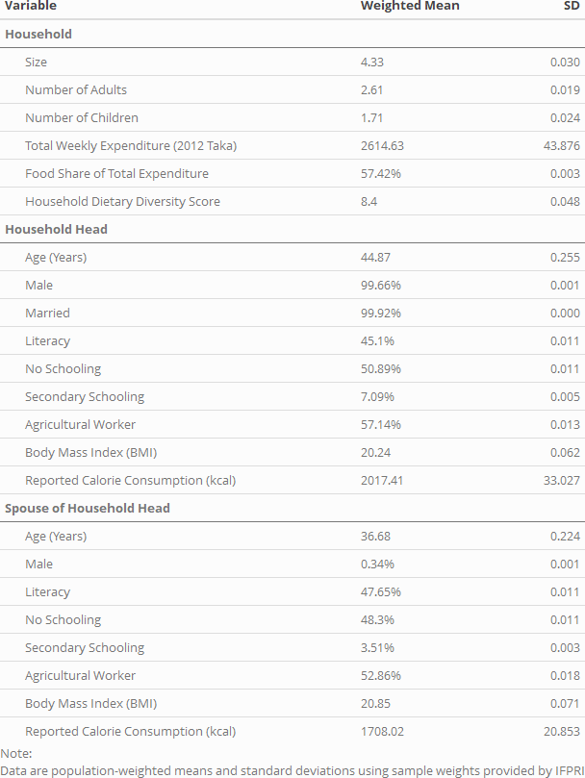

Table 2: Comparison of Weight and Height Reference Standards (IOM, WHO/FAO, India)

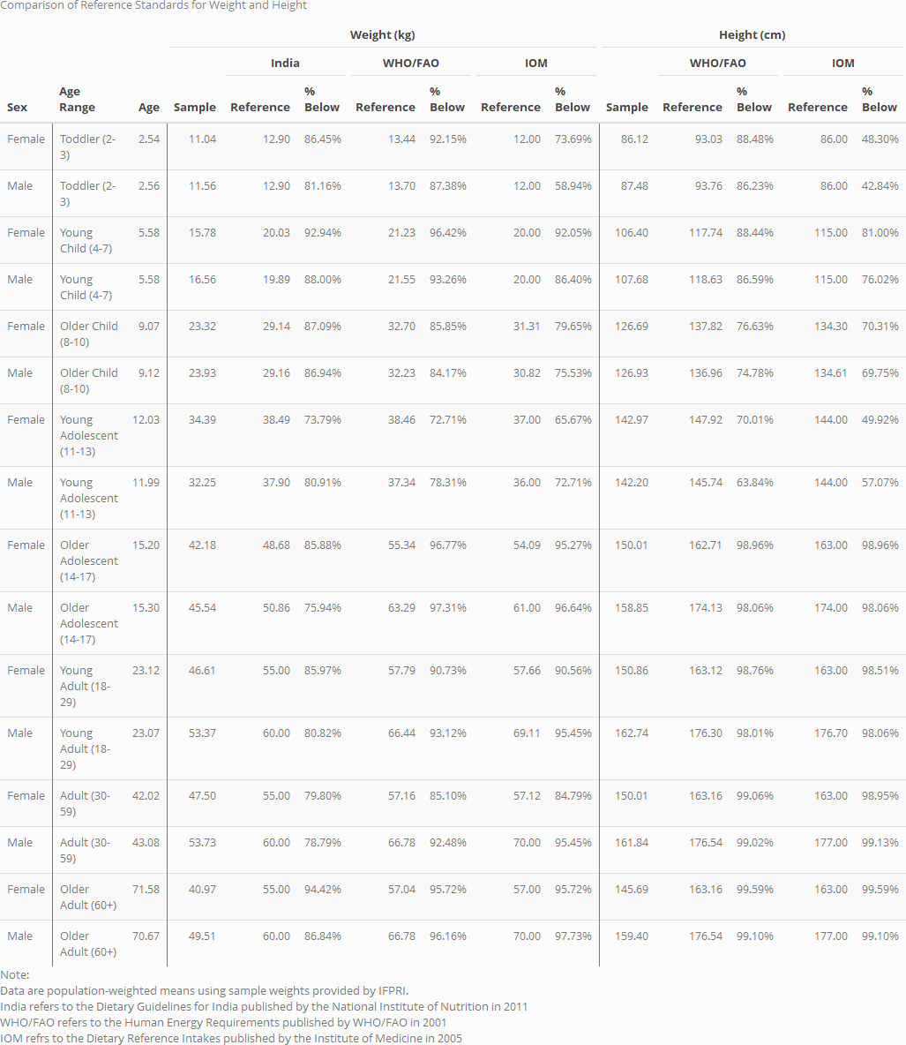

Table 2: Comparison of Adult Equivalents

Table 4: Frequency of Energy Inadequacy

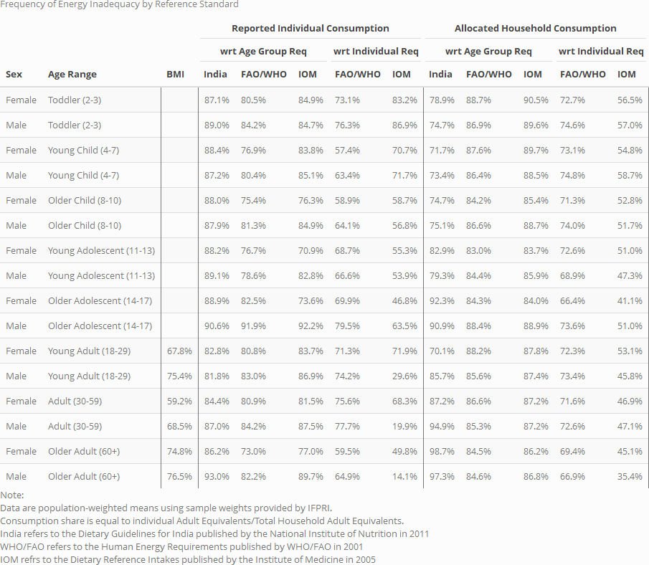

Table 5: Intensity of Energy Inadequacy

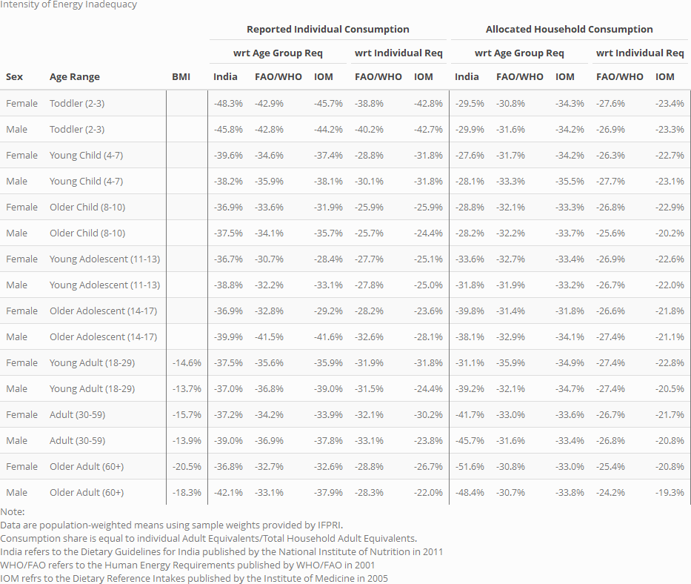

Table 6: Frequency and Intensity of Protein Inadequacy

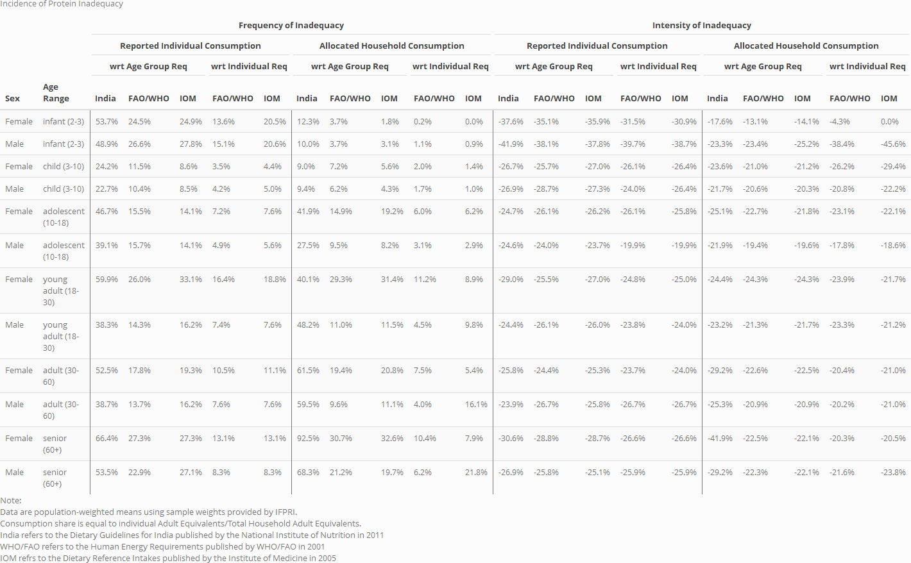

Table 7: Frequency and Intensity of Lipid Inadequacy

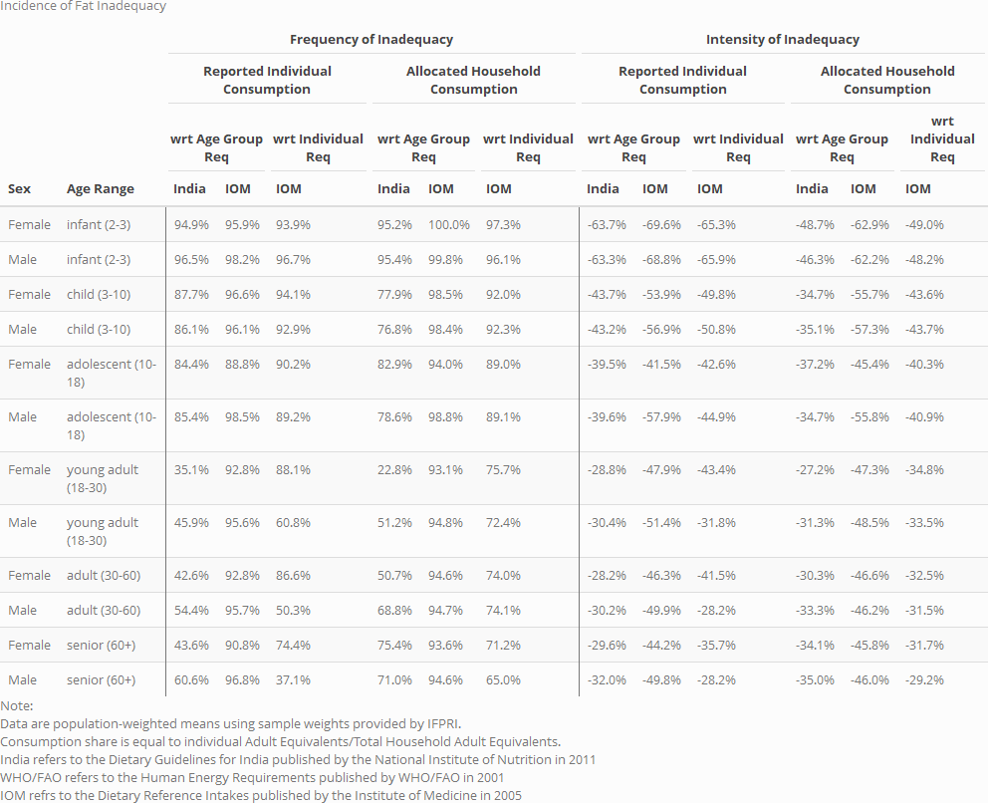

Table 8: Frequency and Intensity of Carbohydrate Inadequacy

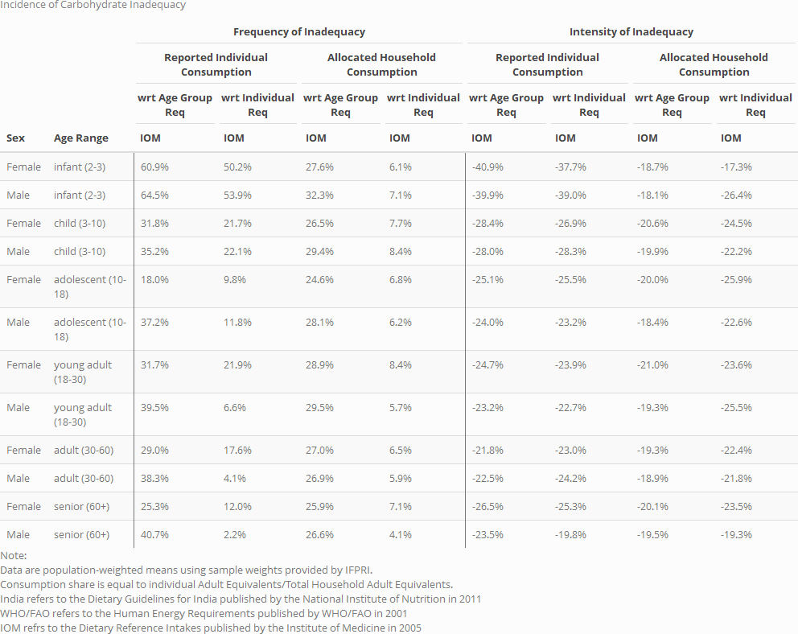

# **References**

Ahmed, A., Ahmad, K., Chou, V., Hernandez, R., Menon, P., Naeem, F., … Yu, B. (2013). The Status of Food Security in the Feed the Future Zone and Other Regions of Bangladesh: Results from the 2011–2012 Bangladesh Integrated Household Survey. Bangladesh Integrated Household Survey, (April), 1–255.

Allen, L.H., A.L. Carriquiry, and S.P. Murphy. (2019). “Perspective: Proposed Harmonized Nutrient Reference Values for Populations.” Advances in Nutrition

Behrman, J. R. (1988). Intrahousehold Allocation of Nutrients in Rural India : Are Boys Favored ? Do Parents Exhibit Inequality Aversion ? *Oxford Economic Papers*, *40*(1), 32–54.

Brown, C., Calvi, R., & Penglase, J. (2018). Sharing the Pie: Undernutrition, Intra-Household Allocation, and Poverty. *SSRN Electronic Journal*, 1–40.

Bermudez, O. I., Lividini, K., Smitz, M. F., & Fiedler, J. L. (2012). Estimating micronutrient intakes from Household Consumption and Expenditures Surveys (HCES): an example from Bangladesh. *Food and Nutrition Bulletin*, *33*(3 Suppl), 208–213.

Berti, P. R. (2012). Intrahousehold distribution of food: A review of the literature and discussion of the implications for food fortification programs. *Food and Nutrition Bulletin*, *33*(3).

Coates, J., Rogers, B. L., Blau, A., Lauer, J., & Roba, A. (2017). Filling a dietary data gap? Validation of the adult male equivalent method of estimating individual nutrient intakes from household-level data in Ethiopia and Bangladesh. *Food Policy*, *72*, 27–42.

Coates, J., Patenaude, B. N., Rogers, B. L., Roba, A. C., Woldetensay, Y. K., Tilahun, A. F., & Spielman, K. L. (2018). Intra-household nutrient inequity in rural Ethiopia. *Food Policy*, *81*, 82–94.

D’Souza, A., & Tandon, S. (2019). Intrahousehold nutritional inequities in rural Bangladesh. *Economic Development and Cultural Change*, *67*(3), 625–657.

Dietary Guidelines for Indians - A Manual. Hyderabad: NIN; 2011. National Institute of Nutrition.

FAO. (2010). Fats and fatty acids in human nutrition. Rome: Food and Agriculture Organization of the United Nations.

FAO. (2012). FAO / INFOODS Guidelines for Food Matching Version 1.2. Rome.

FAO, WHO, and UNU. 2001. Human energy requirements: Report of a Joint FAO/WHO/UNU Expert Consultation. Rome: Food and Agriculture Organization of the United Nations.

FAO, WHO, and UNU. 2002. Protein and amino acid requirements in human nutrition: report of a joint FAO/WHO/UNU expert consultation. Geneva: World Health Organization.

Fiedler, J. L. (2013). Towards overcoming the food consumption information gap: Strengthening household consumption and expenditures surveys for food and nutrition policymaking. *Global Food Security*, Vol. 2, pp. 56–63.

Fiedler, J. L., Carletto, C., & Dupriez, O. (2012). Still waiting for Godot? Improving Household Consumption and Expenditures Surveys (HCES) to enable more evidence-based nutrition policies. *Food and Nutrition Bulletin*, *33*(3 Suppl), 242–251.

Fiedler, J. L., Lividini, K., Bermudez, O. I., & Smitz, M. F. (2012). Household Consumption and Expenditures Surveys (HCES): a primer for food and nutrition analysts in low- and middle-income countries. *Food and Nutrition Bulletin*, *33*(3 Suppl), 170–184.

Gopalan, C., Rama Shastri, B., & Balasubramanian, S. . (1987). Nutritive value of Indian Foods. *Icmr*, p. 117. https://doi.org/10.2307/302397

Haddad, L., Kanbur, R., & Bouis, H. (1994). Intra-Household Inequality and Average Household Well-Being: Evidence on Calorie Intakes and Energy Expenditures from the Philippines. In *Developments in Agricultural Economics* (Vol. 10, pp. 239–257).

Hagenaars, (1994) Poverty statistics in the late 1980s: research based on micro-data. A.J.M. Statistical Office of the European Communities, Luxembourg (Luxembourg) eng De Vos, K. Asghar Zaidi, M.

Institute of Medicine of the National Academies. 2006. Dietary Reference Intakes: the essential guide to nutrient requirements J. J. Otten, J. P. Hellwig, and L. D. Meyers, eds. Washington, DC: National Academies Press.

Institute of Medicine of the National Academies. 2011. Dietary Reference Intakes for Calcium and Vitamin D. Washington, DC: National Academies Press.

Karageorgou, D., Imamura, F., Zhang, J., Shi, P., Mozaffarian, D., & Micha, R. (2018). Assessing dietary intakes from household budget surveys: A national analysis in Bangladesh. *PLoS ONE*, *13*(8), 1–22.

Lividini, K., Fiedler, J. L., & Bermudez, O. I. (2013). Policy implications of using a Household Consumption and Expenditures Survey versus an Observed-Weighed Food Record Survey to design a food fortification program. *Food and Nutrition Bulletin*, *34*(4), 520–532.

Pitt, M. M., Rosenzweig, M. R., & Nazmul Hassan, M. (1990). Productivity , Health , and Inequality in the Intrahousehold Distribution of Food in Low- Income Countries. *The American Economic Review,* *80*(5), 1139–1156.

Schneider, K., & Herforth, A. (2020). Software tools for practical application of human nutrient requirements in food-based social science research. *Gates Open Research*, 1–21.

Steeves, J. A., Tudor-Locke, C., Murphy, R. A., King, G. A., Fitzhugh, E. C., & Harris, T. B. (2015). Classification of occupational activity categories using accelerometry: NHANES 2003-2004. *International Journal of Behavioral Nutrition and Physical Activity*, *12*(1).

Sununtnasuk, C., & Fiedler, J. L. (2017). Can household-based food consumption surveys be used to make inferences about nutrient intakes and inadequacies? A Bangladesh case study. *Food Policy*, *72*, 121–131.

US Department of Agriculture. 2018. USDA National Nutrient Database for Standard Reference, Legacy (2018). Beltsville, Maryland: USDA Agricultural Research Service Nutrient Data Laboratory.

USDA. (2007). USDA Table of Nutrient Retention Factors, Release 6. *National Academy Press*, 18. Retrieved from [www.nal.usda.gov/fnic/foodcomp/Data/retn6/retn06.pdf](http://www.nal.usda.gov/fnic/foodcomp/Data/retn6/retn06.pdf)

WHO Multicentre Growth Reference Study Group. 2006. World Health Organization child growth standards: Methods and development. Geneva: World Health Organization

1. The IOM was renamed the National Academies of Science, Engineering, and Medicine (NASEM).
2. Note that the requirements and methods of measuring inadequacy for iron also differ from most other nutrients (see CITE).